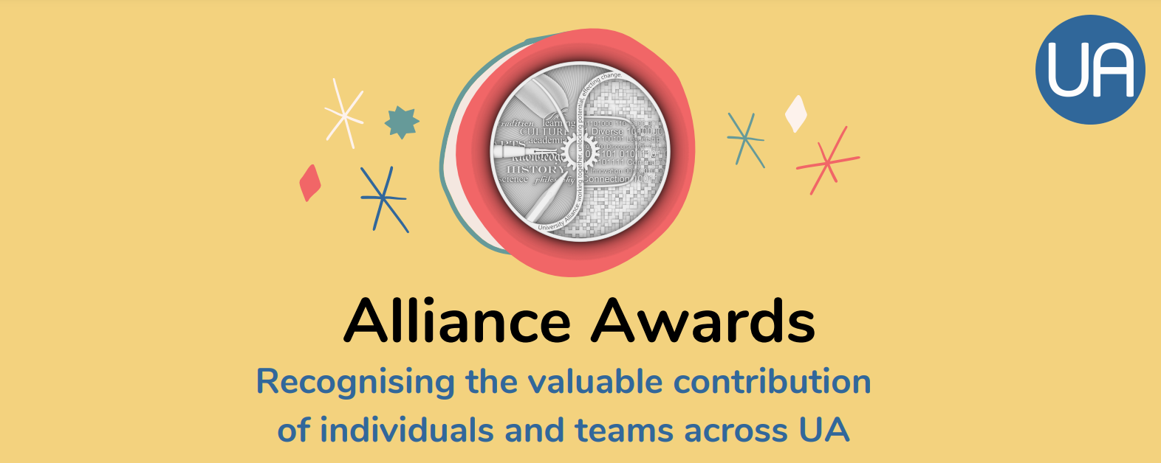
Nomination form

Please complete this pro forma and submit to Awards@unialliance.ac.uk

You should complete one pro forma per nomination, even if you are nominating the same team/organisation for different awards.

Name:

University:

Role:

Award nominating for:

Nomination (max 150 words)

Any other information you would like to provide (you can include images, videos, or links/URLs to further information you would like the judges to consider- these can be linked below or attached in the email. Please note we may look to use any multimedia content as part of the awards event and promotional activity).

